**IICS**

**--------------------IICS SCD TYPE 1--------------------------------**

**-----------------------SOURCE TABLE--------------------------**

**CREATE** **TABLE** [ANITHA_IICS_FA_HC] (

[PID] **float**,

[AGE] **float**,

[GENDER] **nvarchar**(25),

[CATEGORY_NAME] **nvarchar**(25),

[DISTRICT_NAME] **nvarchar**(25),

[PREAUTH_AMT] **float**,

[CLAIM_AMOUNT] **float**,

[HOSP_NAME] **nvarchar**(25),

[SURGERY_DATE] **datetime**,

[DISCHARGE_DATE] **datetime**

);

**SELECT** * **FROM** [ANITHA_IICS_FA_HC]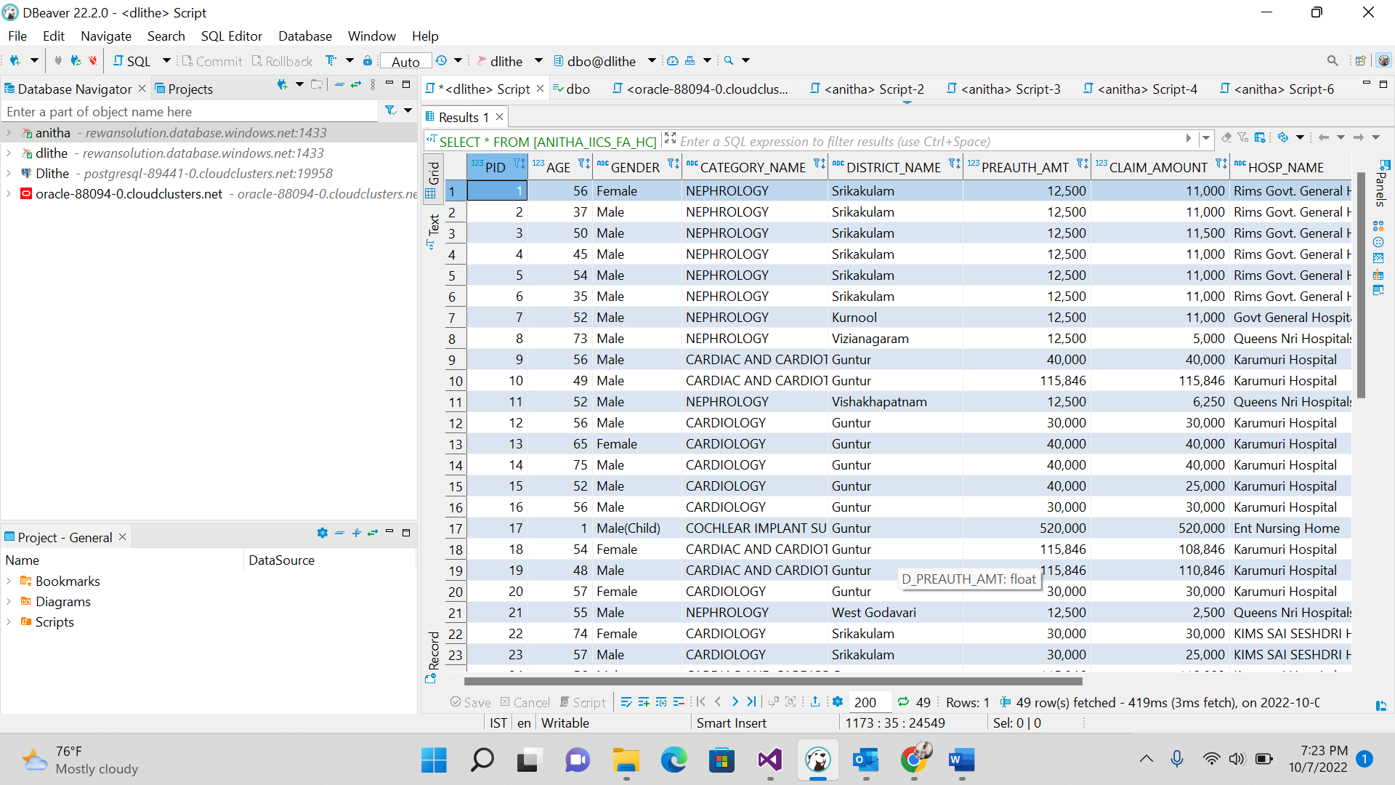

**---------------------------------TARGET TABLE------------------------------**

**CREATE** **TABLE** [ANITHA_HC_FA_IICS_SCD_TGT] (

D_PID **float**,

D_AGE **float**,

D_GENDER **nvarchar**(25),

D_CATEGORY_NAME **nvarchar**(25),

D_DISTRICT_NAME **nvarchar**(25),

D_PREAUTH_AMT **float**,

D_CLAIM_AMOUNT **float**,

D_HOSP_NAME **nvarchar**(25),

D_SURGERY_DATE **datetime**,

D_DISCHARGE_DATE **datetime**,

D_PATIENT_KEY **FLOAT**,

D_CHECKSUM **VARCHAR**(25)

);

**SELECT** * **FROM** [ANITHA_HC_FA_IICS_SCD_TGT];

**SELECT** D_PID, D_CATEGORY_NAME,D_PREAUTH_AMT,D_CLAIM_AMOUNT,

D_HOSP_NAME, D_PATIENT_KEY,D_CHECKSUM **FROM** [ANITHA_HC_FA_IICS_SCD_TGT];

-------------------------------**IICS STEPS--------------------------**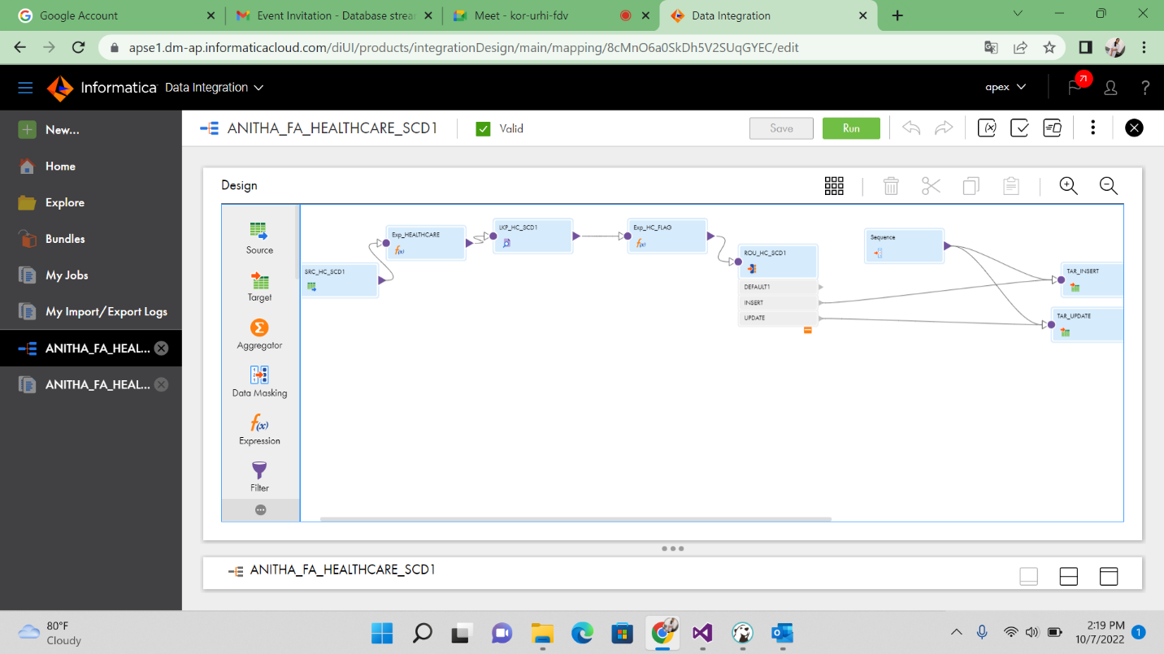

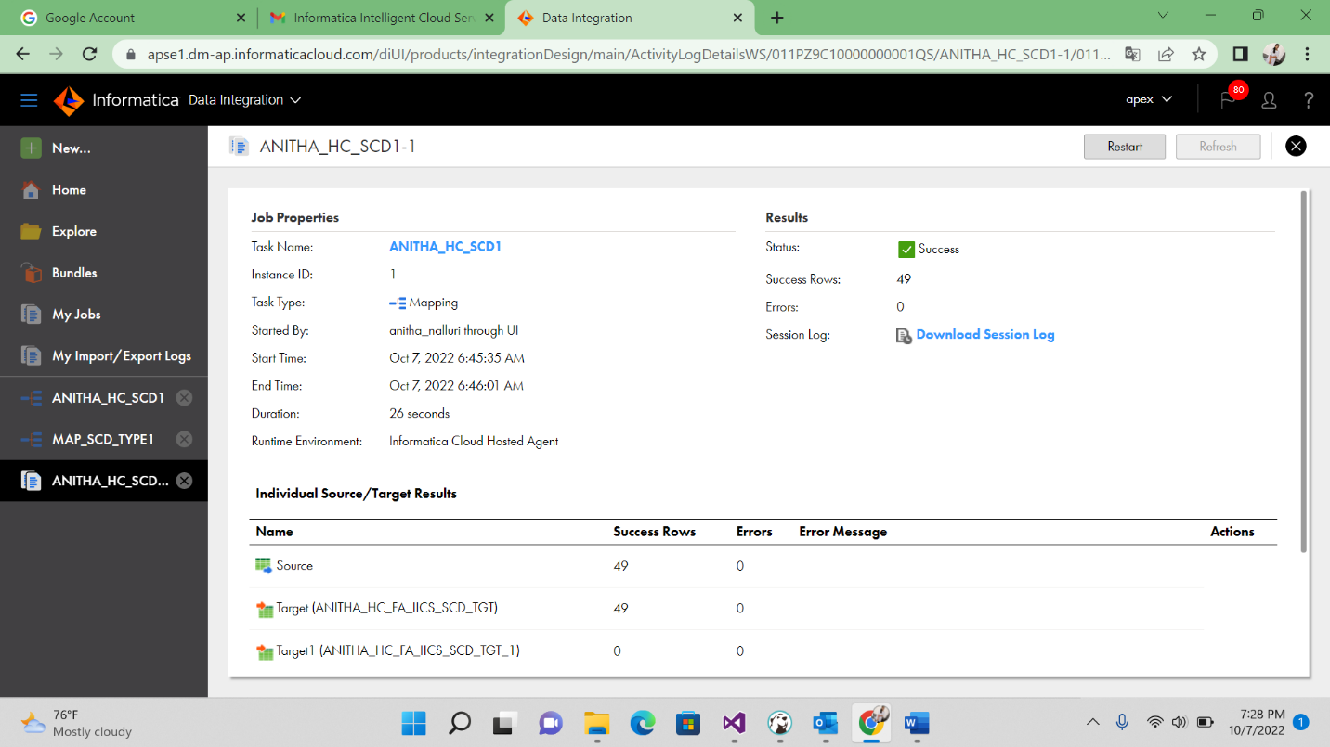

**---------------------------SCD1 OUTPUT--------------------------**

**---------------------------UPDATE IN SCD1-------------------------**

**UPDATE** [ANITHA_IICS_FA_HC]

**SET** CATEGORY_NAME='CARDIOLOGY' **WHERE** PID=1;

**SELECT** D_PID, D_CATEGORY_NAME,D_PREAUTH_AMT,D_CLAIM_AMOUNT,

D_HOSP_NAME, D_PATIENT_KEY,D_CHECKSUM **FROM** [ANITHA_HC_FA_IICS_SCD_TGT];

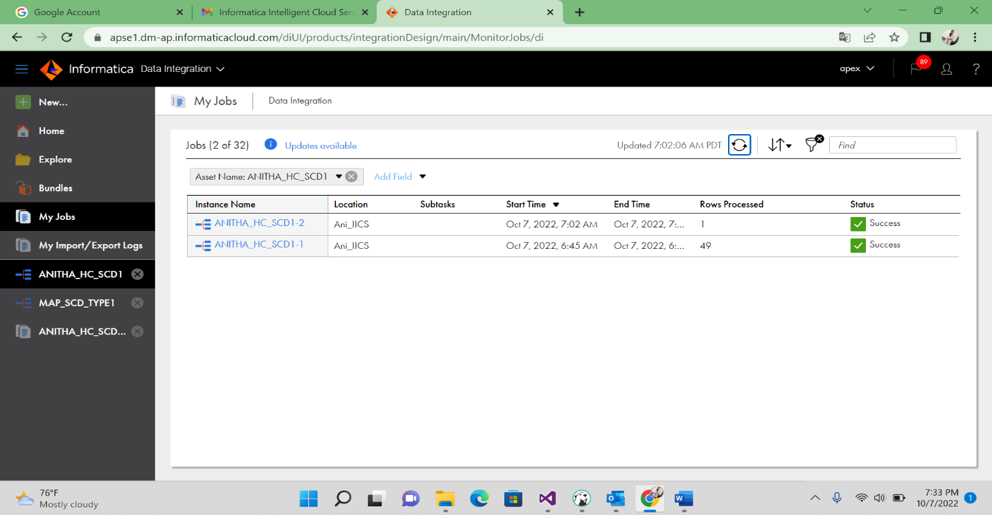

**-----------------------------OUTPUT OF THE UPDATED VALUE----------------**

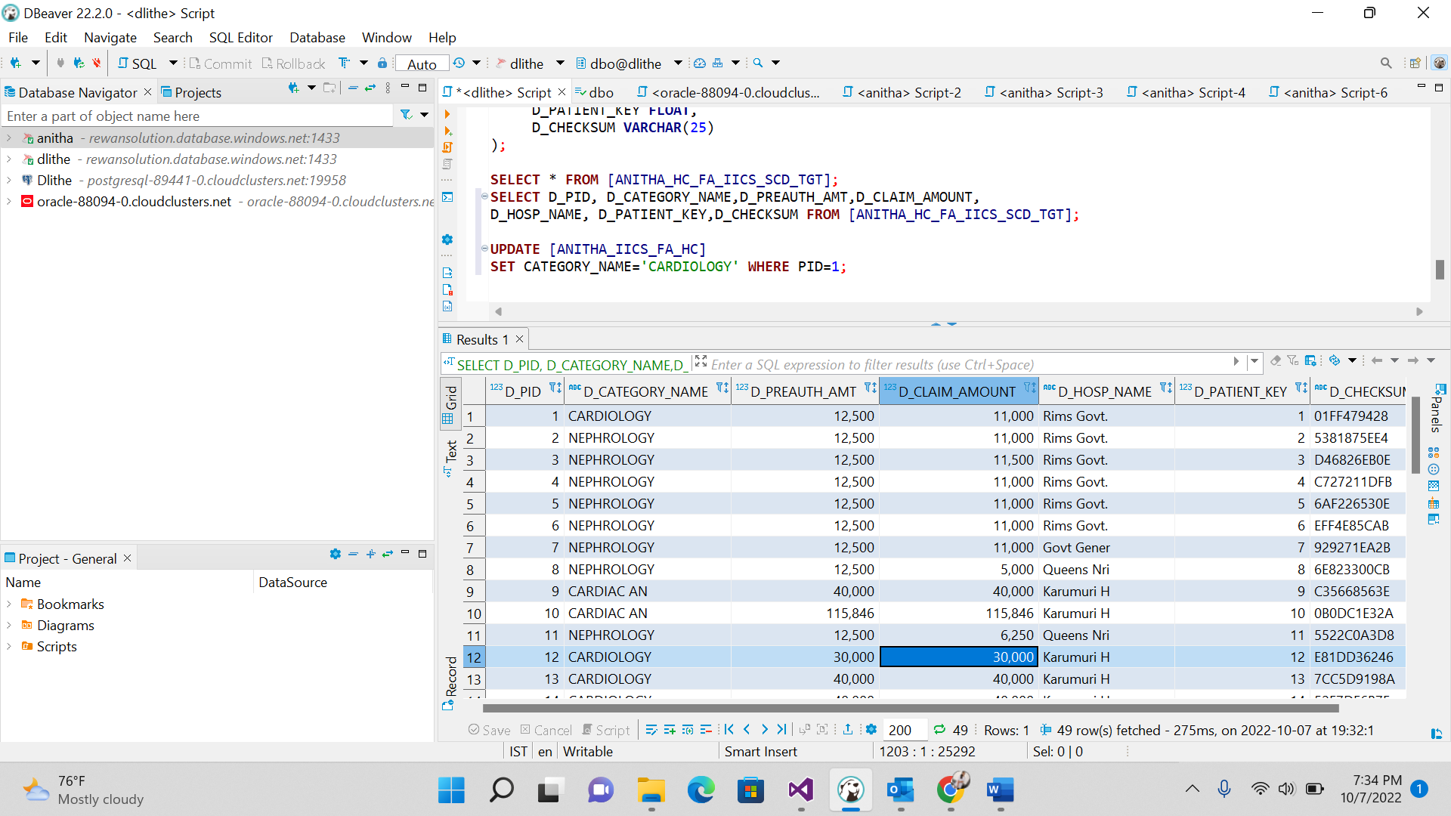

**----------------------------------------IICS SCD TYPE 2---------------------------**

**---------------------------SOURCE TABLE----------------------------**

**CREATE** **TABLE** [ANITHA_IICS_FA_HC] (

[PID] **float**,

[AGE] **float**,

[GENDER] **nvarchar**(25),

[CATEGORY_NAME] **nvarchar**(25),

[DISTRICT_NAME] **nvarchar**(25),

[PREAUTH_AMT] **float**,

[CLAIM_AMOUNT] **float**,

[HOSP_NAME] **nvarchar**(25),

[SURGERY_DATE] **datetime**,

[DISCHARGE_DATE] **datetime**

);

**SELECT** * **FROM** [ANITHA_IICS_FA_HC];

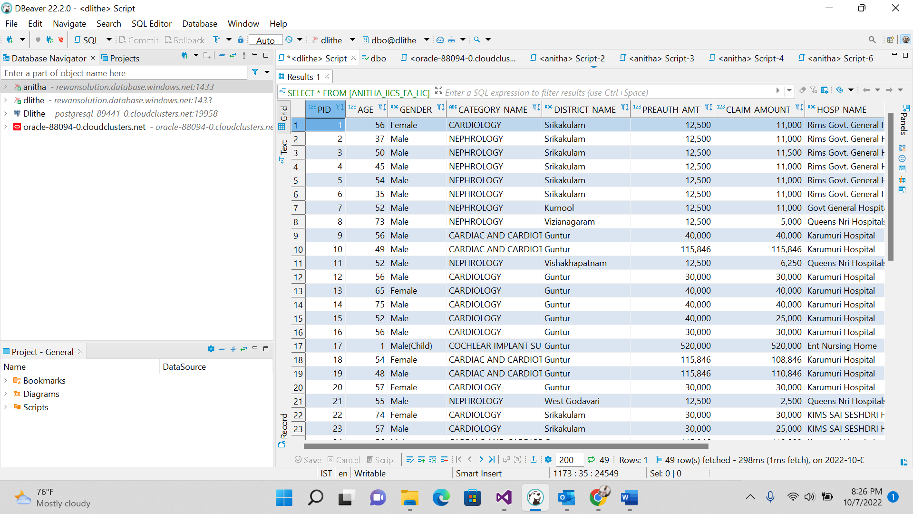

**-----------------------TARGET TABLE------------------------------**

----------------------------------------TARGET TABLE FOR SCD2-----------------------

**CREATE** **TABLE** [ANITHA_HC_FA_IICS_SCD2_TGT] (

D_PID **float**,

D_AGE **float**,

D_GENDER **nvarchar**(25),

D_CATEGORY_NAME **nvarchar**(25),

D_DISTRICT_NAME **nvarchar**(25),

D_PREAUTH_AMT **float**,

D_CLAIM_AMOUNT **float**,

D_HOSP_NAME **nvarchar**(25),

D_SURGERY_DATE **datetime**,

D_DISCHARGE_DATE **datetime**,

D_PATIENT_KEY **FLOAT**,

D_CHECKSUM **VARCHAR**(25)

);

**SELECT** * **FROM** [ANITHA_HC_FA_IICS_SCD2_TGT];

**SELECT** D_PID, D_CATEGORY_NAME,D_PREAUTH_AMT,D_CLAIM_AMOUNT,

D_HOSP_NAME, D_PATIENT_KEY,D_CHECKSUM,D_SURGERY_DATE,

D_DISCHARGE_DATE **FROM** [ANITHA_HC_FA_IICS_SCD2_TGT];

--------------------------**IICS STEPS-----------------------------**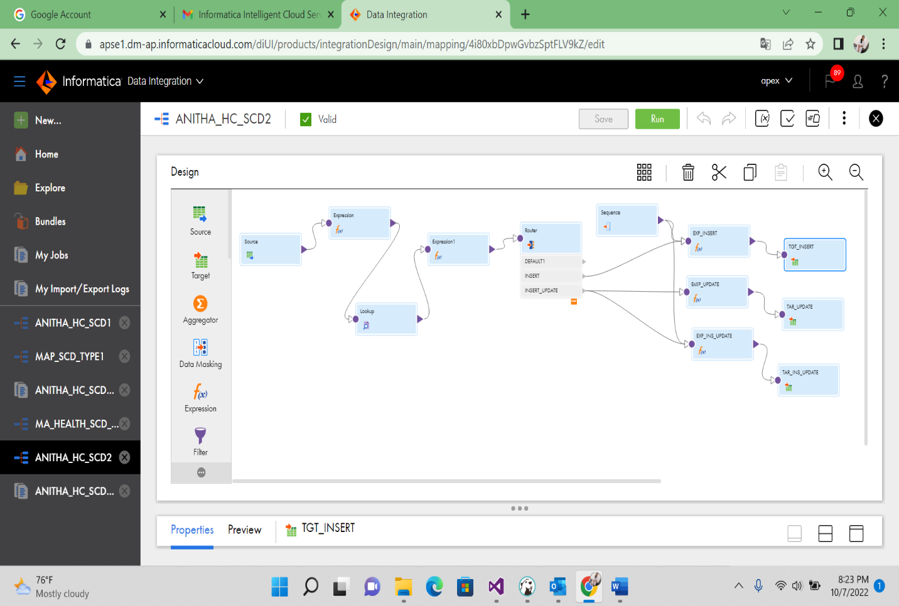

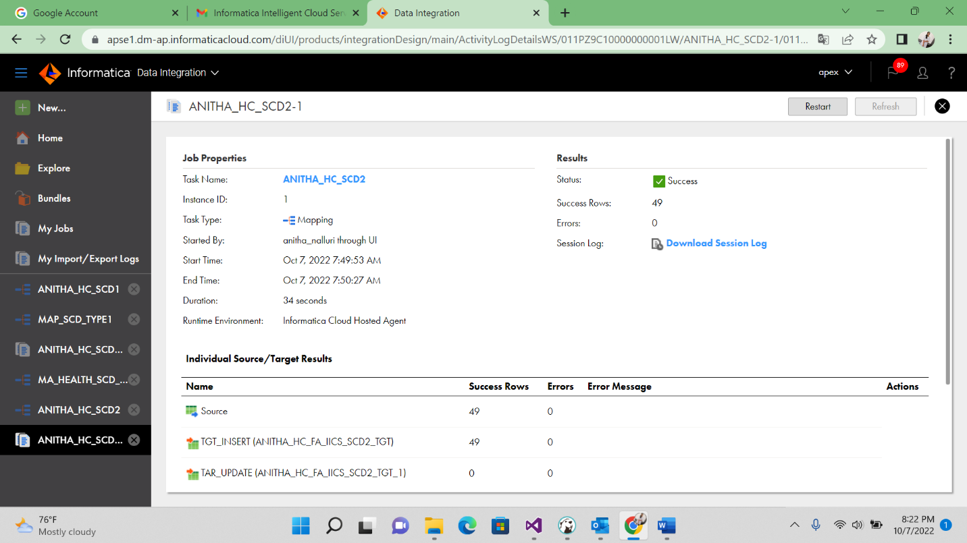

**--------------------------------------------SCD2 OUTPUT-----------------------------**

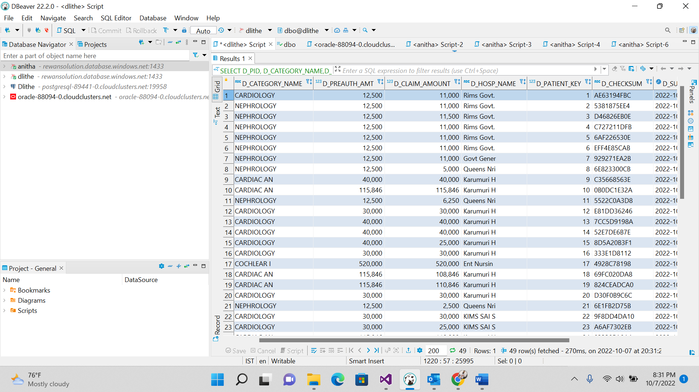

**--------------------------------UPDATING THE VALUES-----------------------**

**UPDATE** [ANITHA_IICS_FA_HC]

**SET** CATEGORY_NAME='DERMATOLOGY' **WHERE** DISTRICT_NAME='Srikakulam';

**SELECT**\* **FROM** [ANITHA_IICS_FA_HC];

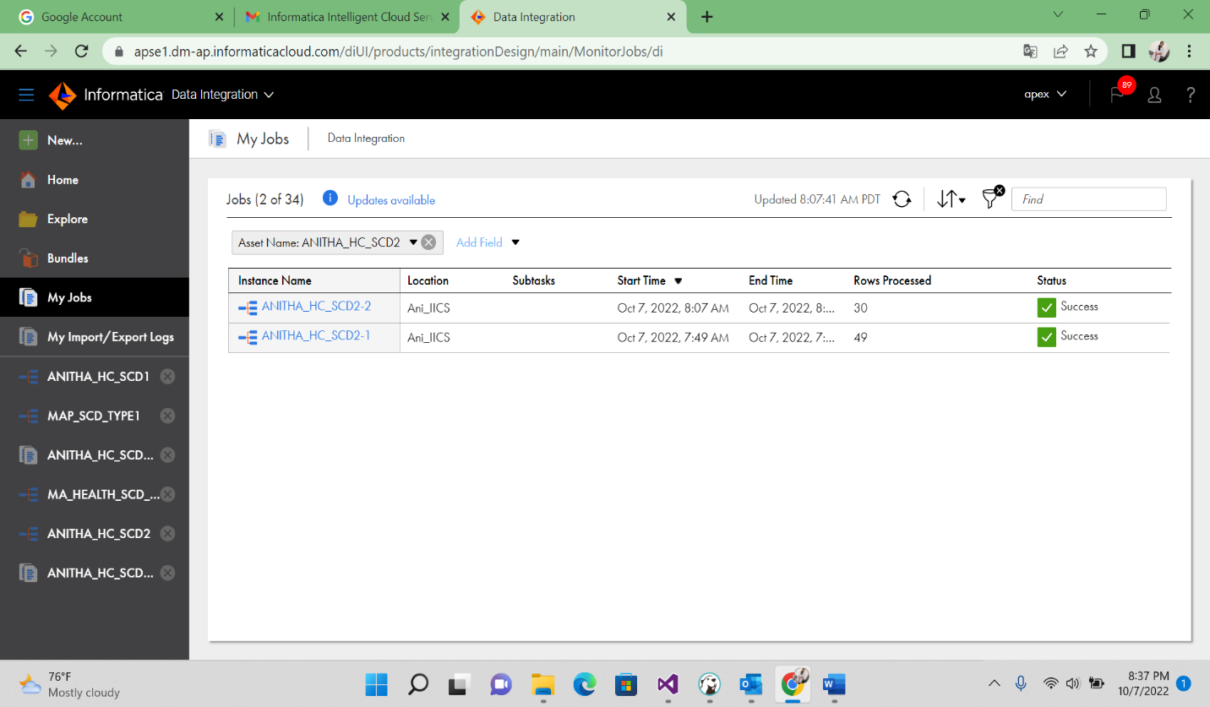

**----------------------OUTPUT OF THE UPDATED VALUE-----------------**

**SELECT** * **FROM** [ANITHA_HC_FA_IICS_SCD2_TGT];

**SELECT** D_PID, D_CATEGORY_NAME,D_PREAUTH_AMT,D_CLAIM_AMOUNT,

D_HOSP_NAME, D_PATIENT_KEY,D_CHECKSUM,D_SURGERY_DATE,

D_DISCHARGE_DATE **FROM** [ANITHA_HC_FA_IICS_SCD2_TGT];

We will get an historical data in SCD Type 2:

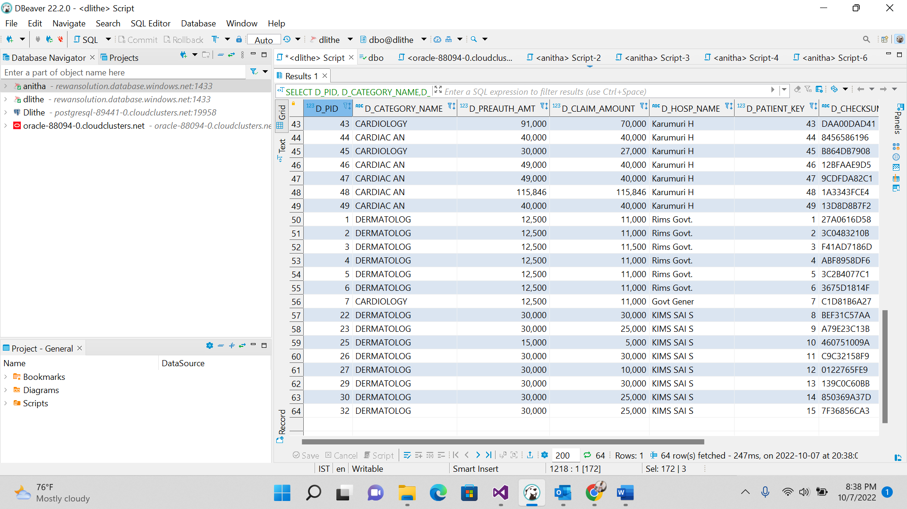

----------------------------USING AGGREGATE FUNCTION-----------------------

Source Table will Be the Same which we used for SCD1 and SCD2

**CREATE** **TABLE** [ANITHA_IICS_FA_HC] (

[PID] **float**,

[AGE] **float**,

[GENDER] **nvarchar**(25),

[CATEGORY_NAME] **nvarchar**(25),

[DISTRICT_NAME] **nvarchar**(25),

[PREAUTH_AMT] **float**,

[CLAIM_AMOUNT] **float**,

[HOSP_NAME] **nvarchar**(25),

[SURGERY_DATE] **datetime**,

[DISCHARGE_DATE] **datetime**

);

**SELECT** * **FROM** [ANITHA_IICS_FA_HC];

------------------IICS STEPS TO USE AGGREGATE FUNCTION--------------------------

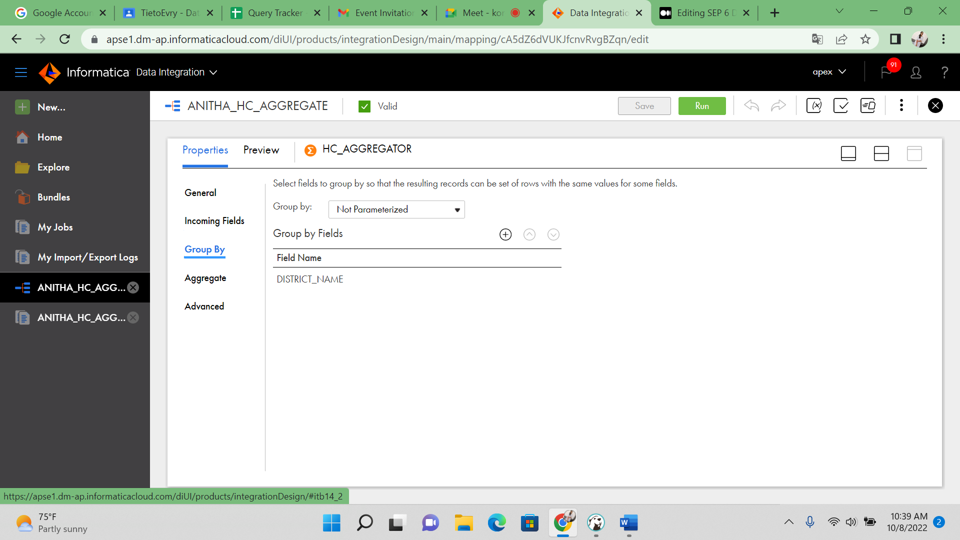

--------------------------TARGET TABLE FOR AGGREGATE -------------------------------------

-------------------------------- AGGREGATE FUNCTION -------------------------------

**CREATE** **TABLE** [ANITHA_IICS_FA_HC_TGT] (

[PID] **float**,

[AGE] **float**,

[GENDER] **nvarchar**(25),

[CATEGORY_NAME] **nvarchar**(25),

[DISTRICT_NAME] **nvarchar**(25),

[PREAUTH_AMT] **float**,

[CLAIM_AMOUNT] **float**,

[HOSP_NAME] **nvarchar**(25),

[SURGERY_DATE] **datetime**,

[DISCHARGE_DATE] **datetime**

);

**SELECT** * **FROM** [ANITHA_IICS_FA_HC_TGT];

**------------------------OUTPUT OF AAGREGATE FUNCTION---------------------**

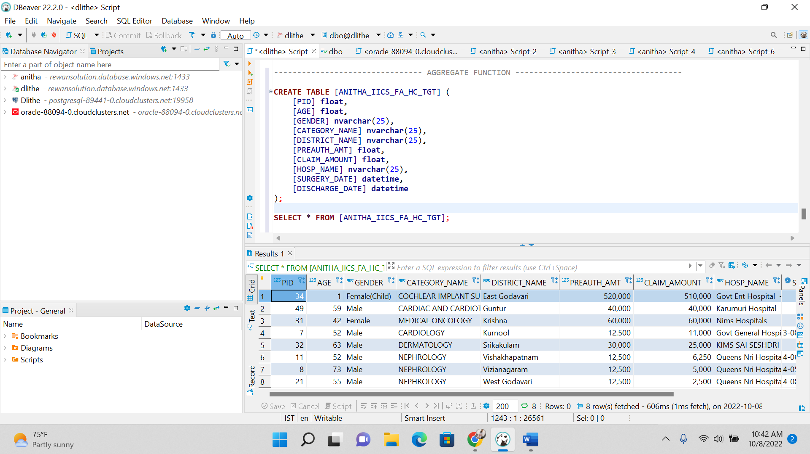

**--------------------R EPLICATION TASK STEPS -------------------------------------**

**1.SOURCE CONNECTION**

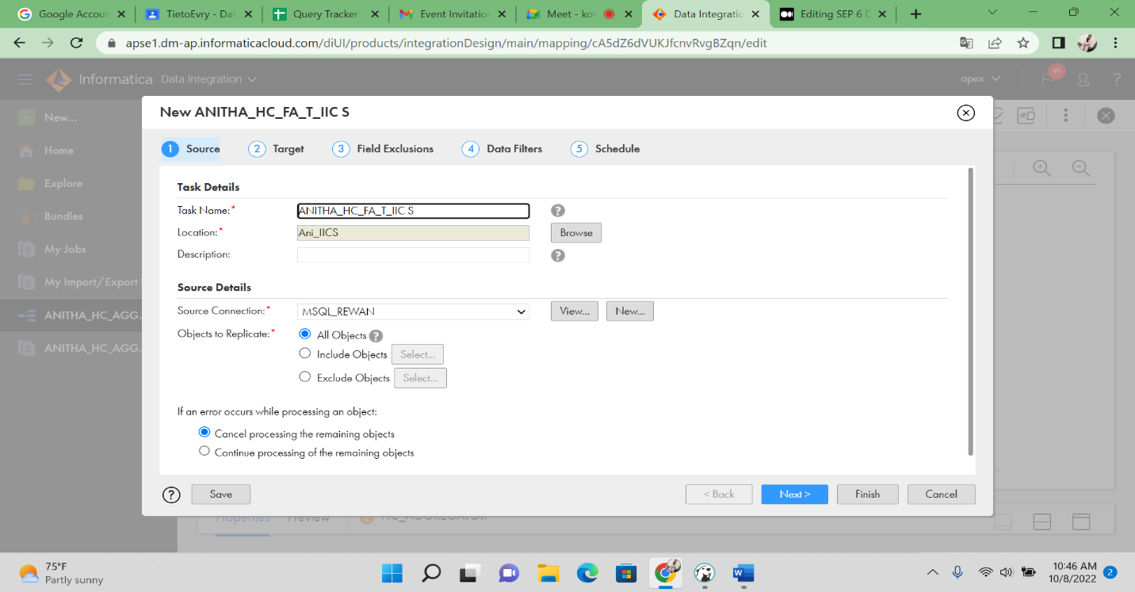

**2.TARGET CONNECTION**

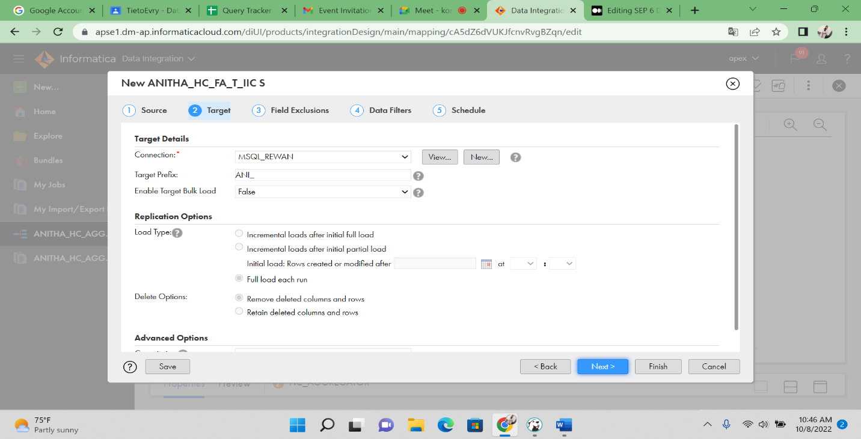

**3.DATA FIELDS**

**4.SCHEDULE THE TASK**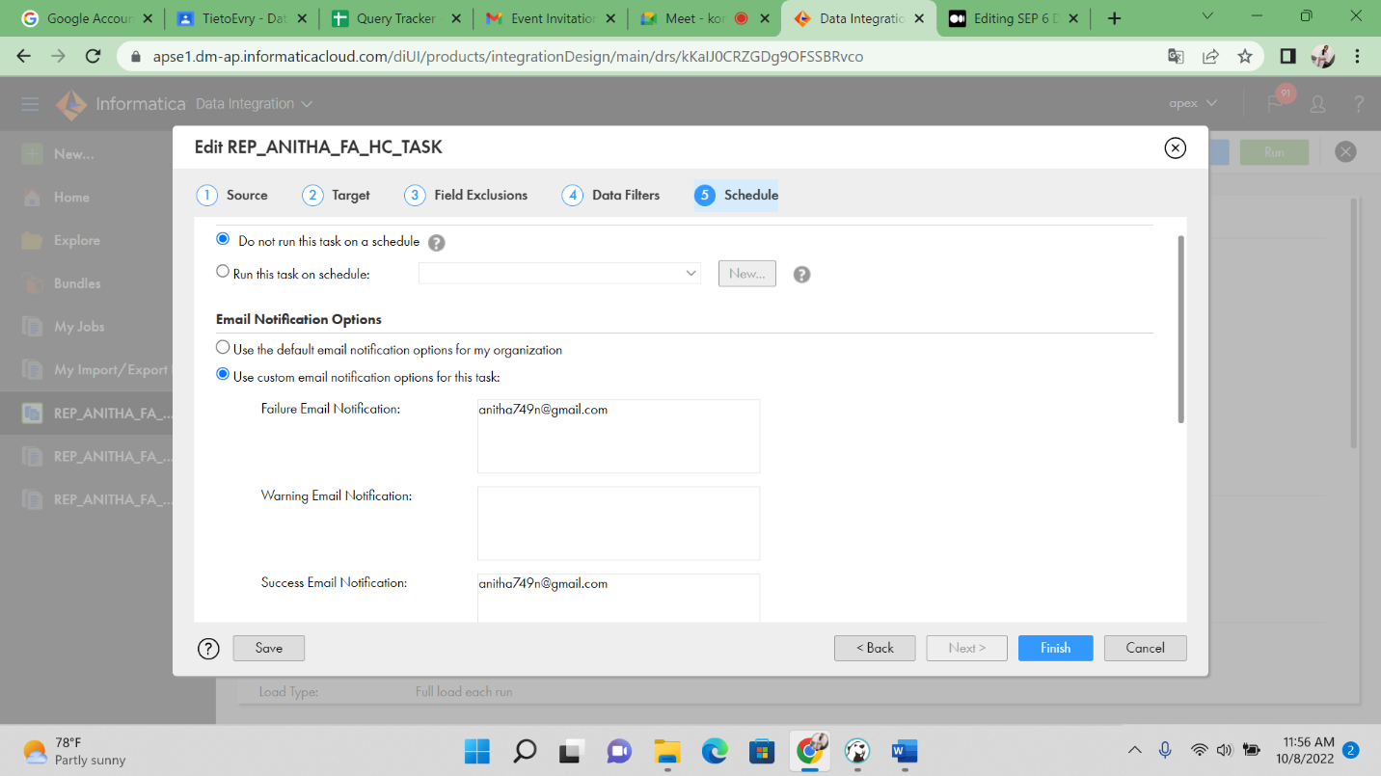

**5.OUTPUT OF REPLICATION TASK**

